Getting Started with the Participant Portal
Guide Table of Contents
Accessing the SuperAgers Study Recruitment Page 1
Enrolling in the SuperAgers Study 2
Applicant is 95 Years & Older 2
Applicant is Not 95 Years of Age 4
Study Registration 4
Registering Using an Email Address 4
Registering Using a Mobile Number 4

Accessing the SuperAgers Study Recruitment Page
- Navigate to the afar SuperAgers Study enrollment page: https://www.superagersstudy.org/.
If you would like to view more information about the study before proceeding through enrollment, use the following links at the top-right of the page for more details:
- How To Enroll – This page will walk you through the high-level steps you’ll take to enroll and participate in the study.
- Our Team – This page provides brief introductions to the team members supporting the SuperAgers study.
- Your Privacy – This page emphasizes our commitment to protecting your privacy and details how your data will be kept safe.
- FAQs – This page provides responses to frequently asked questions. You should leverage this page if you have questions and click 'contact us’ at the top of the page if you need further assistance.
- News – This page shares various publications on the SuperAgers study and its impact.
- More – This page provides contact information if you need to reach out to the SuperAgers study team.



Enrolling in the SuperAgers Study
- Click the ‘Enroll Now’ button.

- After clicking ‘Enroll Now,’ you will be asked a screening question(s) to determine if you are eligible for the study.

Applicant is 95 Years & Older
- If you are 95 years or older, select ‘Yes,’ and click, ‘Next Page.’
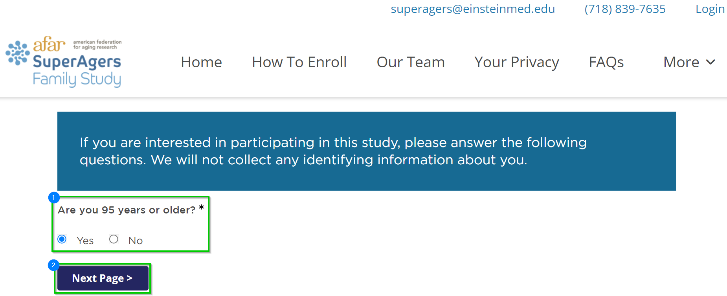
- Click the ‘Click Here to Register!’ button if you would like to proceed with enrollment in the SuperAgers study.
  - If you would not like to proceed with enrollment, close or navigate away from the site.
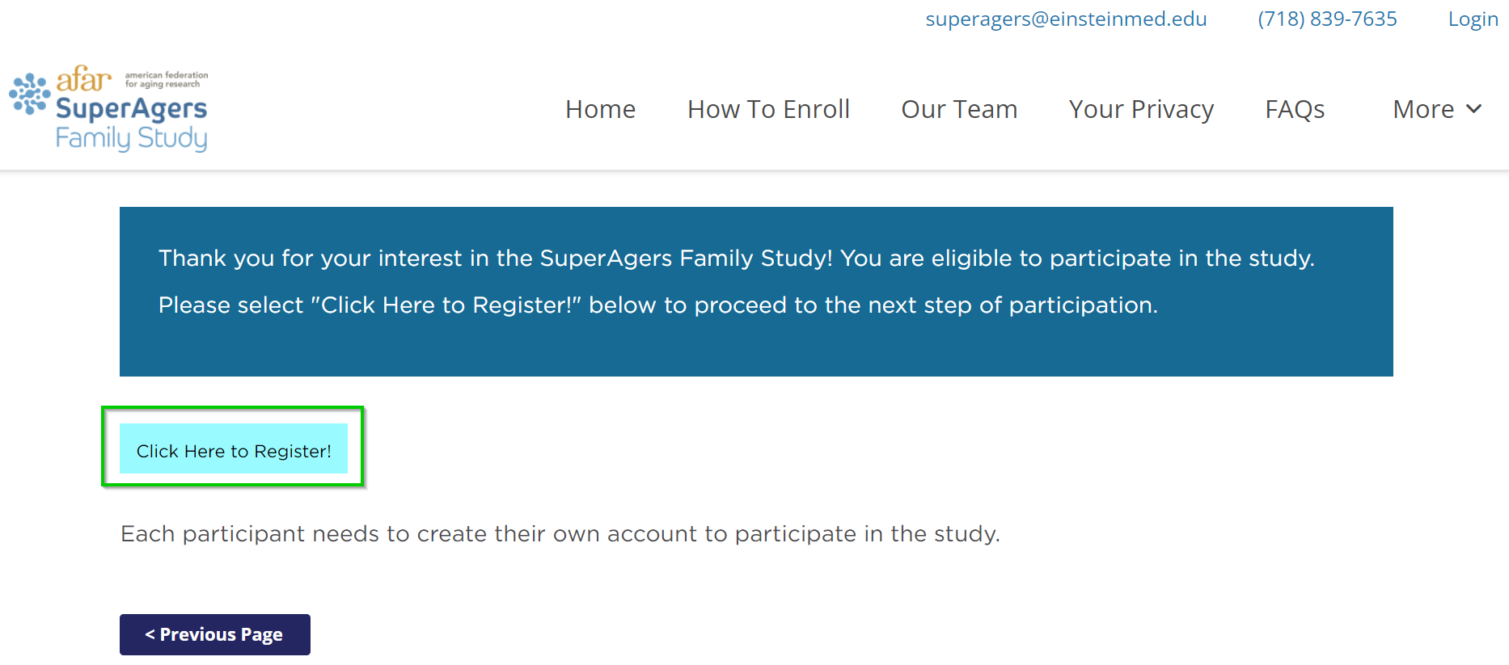
- After clicking, ‘Click Here to Register!,’ you will be brought to the Vibrent Participant Portal to complete your registration.

Follow the steps here to create your Participant Portal account and complete registration for the SuperAgers study.

Applicant is Not 95 Years of Age

- If you are 95 years or older, select ‘Yes,’ and click ‘Next Page >.’
- If you are not 95 years or older, click ‘No,’ and answer the subsequent question depending on if you have a living relative who is 95 years old or older.
- Click

  - If you are under 95 years of age, select, ‘No.’
  - Answer the next screening question: ‘Do you have a family member or know someone who is 95 years or older who is currently alive?*
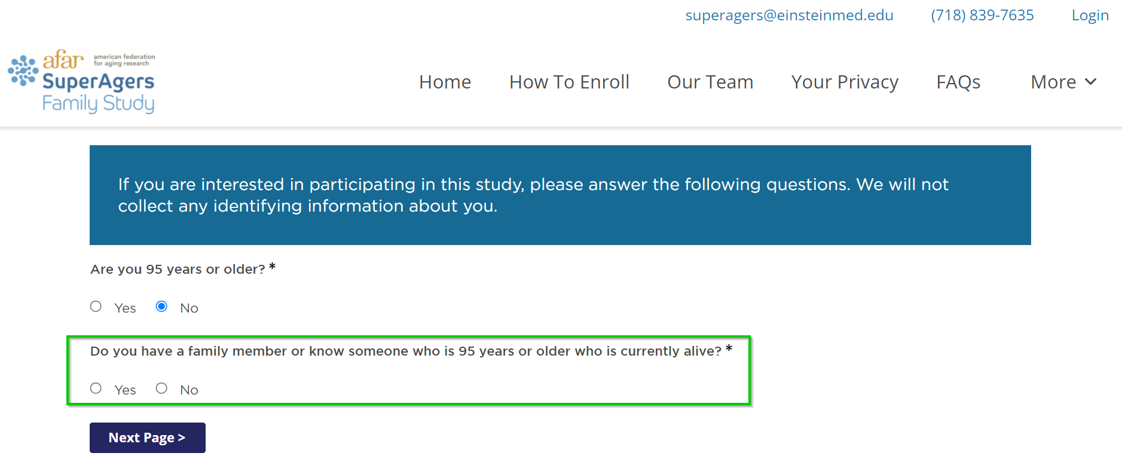
    - not, click, ‘No.’
    - If you do, click ‘Yes.’
- Click, ‘Next Page >.’

- Do you still want to register for the study?
  - If not, close the window.
  - If yes, select the ‘Click Here to Register!’ button to proceed.

Study Registration
Before you can complete your registration and consent for the SuperAgers study, you will need to create a Participant Portal account. Registration can be done using an email address or a phone number.
Please be aware of the following, before you proceed to create an account:
- An email address or a mobile number can only be used once. You cannot use the same email or phone number to create another account.
- Make sure you can quickly and easily access the email address or mobile number you use to register.
  - A verification code will be sent for you to enter before your account will be created.

Registering Using an Email Address
- From the Participant Portal home page: https://SuperAgersStudy.vibrenthealth.com, enter your email address and a password to use for your account that meets the requirements – the password must include:
  - Eight (8) characters, minimum
  - One (1) capital letter
  - One (1) lowercase letter
  - One (1) number
  - One (1) symbol (@#$%^&*?!-_)
- Click ‘Continue.’
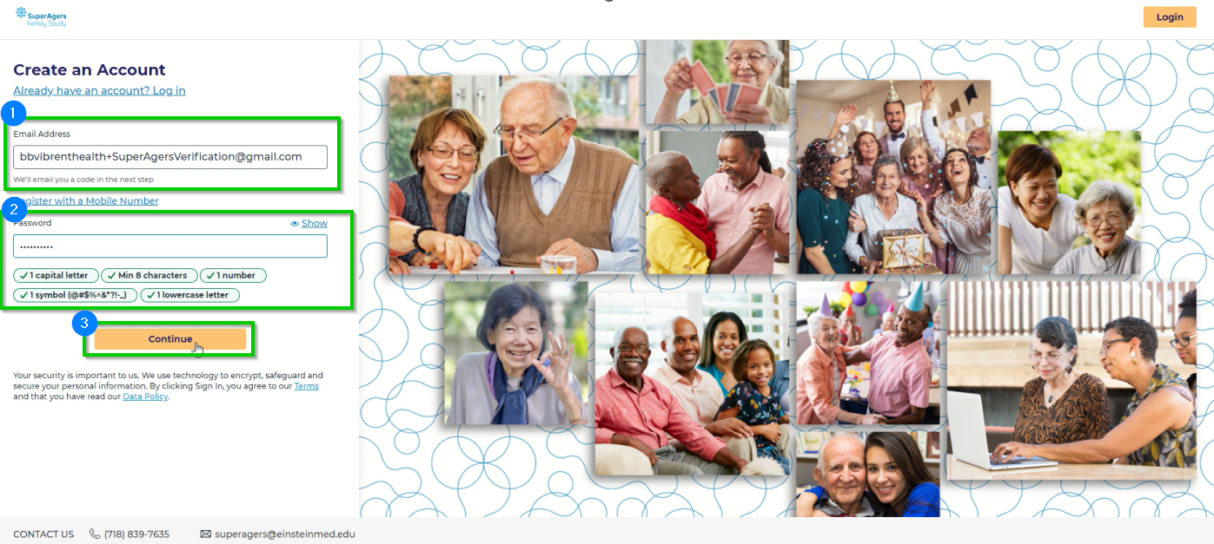
- Open you email account and find the email from the Research Team
- Copy the code in the email, and navigate back to the Portal
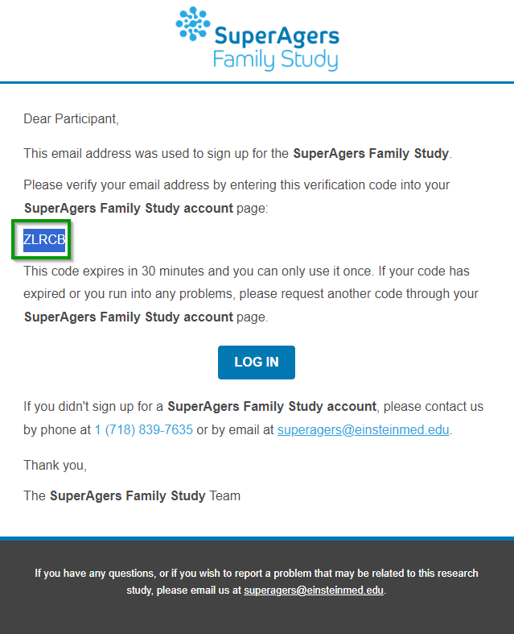
- Back in the Portal, paste the verification code you copied into the field, and click ‘Continue.’
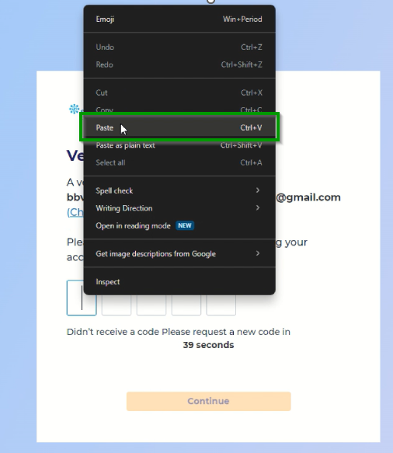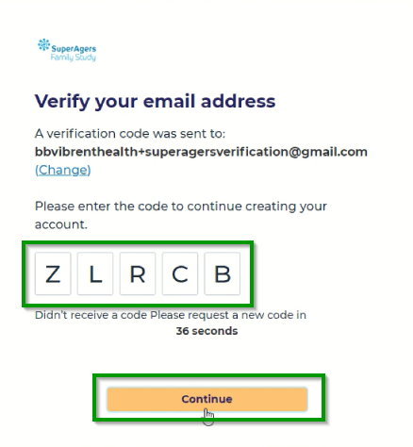
- Enter your zip code on the next screen and click ‘Continue.’
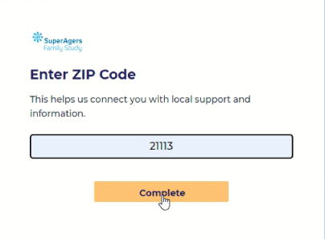
- You are now registered for the Portal! Click ‘Get Started,’ to begin your journey and complete your consent for the study.
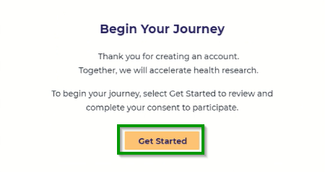

Registering Using a Mobile Number
- From the registration screen, click the blue ‘Register with a Mobile Number,’ link.
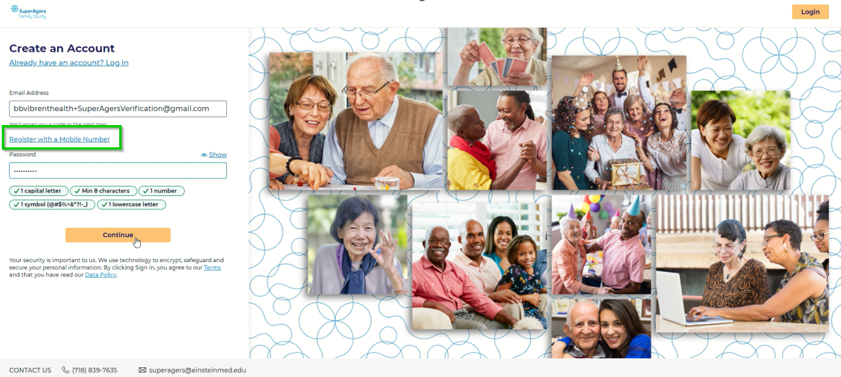
- Enter your mobile number and a password to use for your account that meets the requirements – the password must include:
  - Eight (8) characters, minimum
  - One (1) capital letter
  - One (1) lowercase letter
  - One (1) number
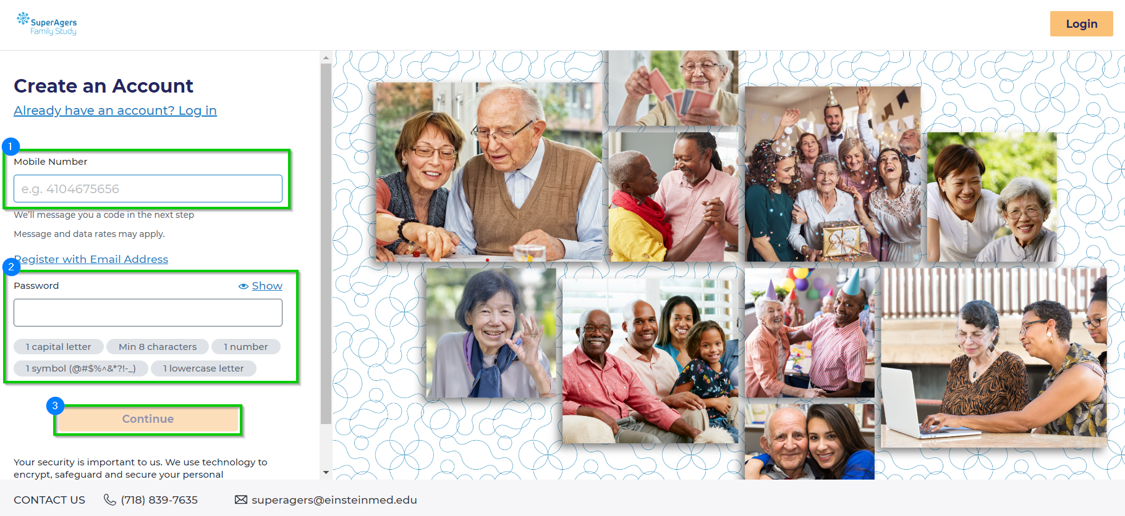
- Click ‘Continue.’
- Enter the verification code sent to your mobile number.
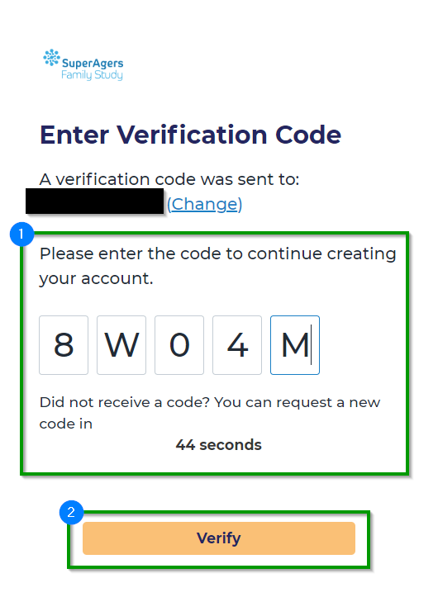
- Click ‘Verify.’
- On the next screen, enter your zip code, and click ‘Complete.’
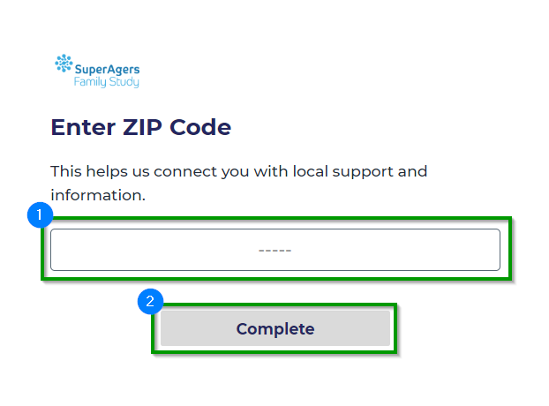
- You are now registered for the Portal! Click ‘Get Started,’ to begin your journey and complete your consent for the study.
